Set: unordered collection data type that is iterable, mutable and has no duplicate elements.

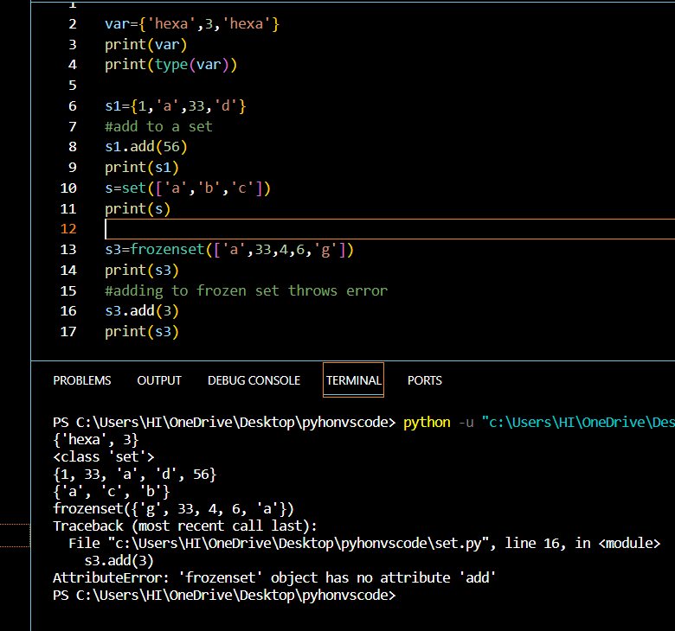

Frozen set in Python are immutable objects that only support methods and operators that produce a result without affecting the frozen set or sets to which they are applied.

So above when adding a element to frozen set it gives error.

Set operators:

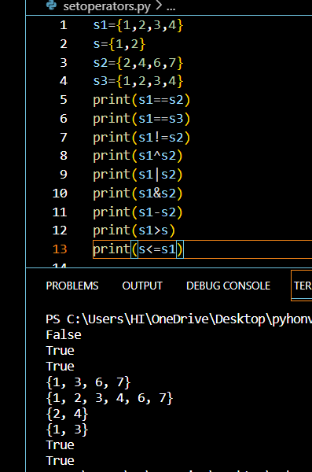

Set union and intersection:

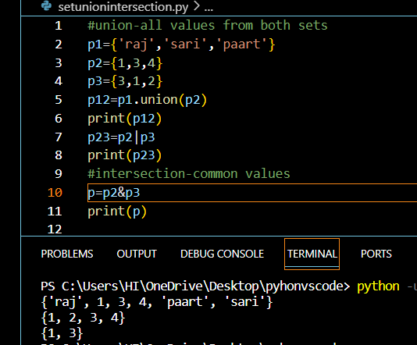

Set difference:

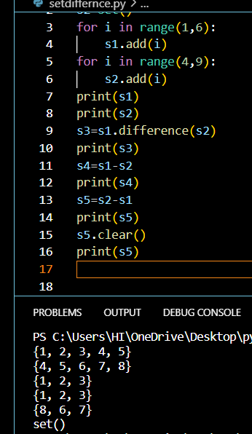

Set methods:

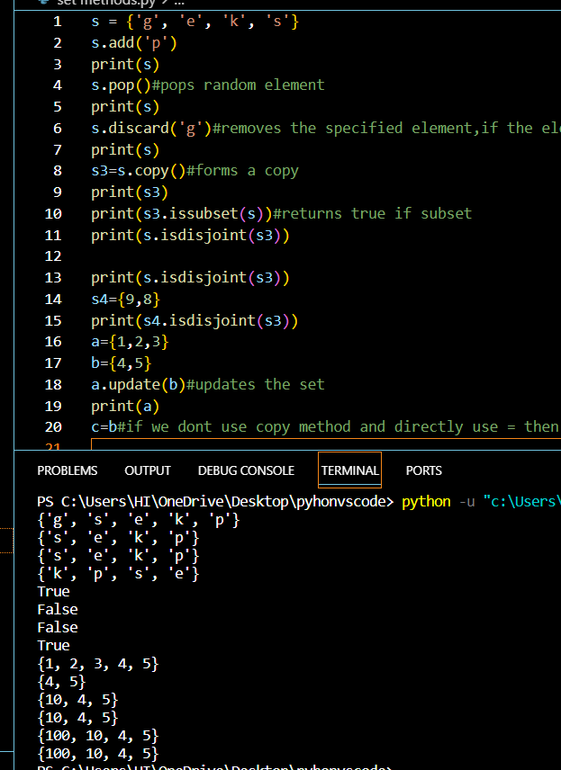

Set time complexity:

| **Operation** | **Average case** | **Worst Case** | **notes** |
| --- | --- | --- | --- |
| x in s | O(1) | O(n) |  |
| Union s|t | O(len(s)+len(t)) |  |  |
| Intersection s&t | O(min(len(s), len(t)) | O(len(s) * len(t)) | replace “min” with “max” if t is not a set |
| Multiple intersection s1&s2&..&sn |  | (n-1)*O(l) where l is max(len(s1),..,len(sn)) |  |
| Difference s-t | O(len(s)) |  |  |

Functions:

Is a block of statements that returns the same task.for better code readability,usability.

There are

Built in functions

Userdefined functions

Simple function to understand the structure:

Types of arguments:

Default

Keyword

Positional

Arbitrary

Default arguments:the value is given by default at creation so if it is not given while calling then the default value gets taken.

Keyword argument: The idea is to allow the caller to specify the argument name with values so that the caller does not need to remember the order of parameters.

Positional arguments:

By changing the position, or if you forget the order of the positions, the values can be used in the wrong places

Arbitrary arguments:

In Python Arbitrary Keyword Arguments, *args, and **kwargs can pass a variable number of arguments to a function using special symbols

Anonymus function;

Map function:

function returns a map object(which is an iterator) of the results after applying the given function to each item of a given iterable (list, tuple etc.)

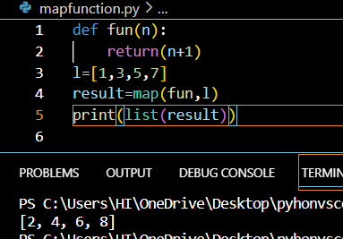

Adding 2 lists using map function:

